**Chapter 1**

**Introduction**

* 1. **Definition and Importance**

Customer segmentation is the process of dividing a customer base into distinct groups of individuals who share similar characteristics. This segmentation allows businesses to target these groups more effectively and tailor marketing strategies to meet their specific needs.

* **Enhances Personalisation:** By understanding different customer segments, companies can create more personalized marketing campaigns, products, and services.
* **Improves Customer Satisfaction:** Tailored offerings improve customer satisfaction and loyalty, as customers feel understood and valued.
* **Increases Revenue:** Effective segmentation can lead to increased sales and higher conversion rates, as marketing efforts are more precisely targeted.
  1. **Traditional Methods of Customer Segmentation**

Traditional customer segmentation methods often rely on basic demographic data such as age, gender, income, and geographic location. Some common traditional methods include:

* **Demographic Segmentation:** Dividing customers based on demographic factors like age, gender, and income.
* **Geographic Segmentation:** Segmenting customers based on their geographical location.
* **Psychographic Segmentation:** Classifying customers based on their lifestyle, interests, values, and attitudes.
* **Behavioral Segmentation:** Grouping customers based on their purchasing behavior, product usage, and brand interactions.
  1. **Advantages of Using AI and ML for Customer Segmentation**

Artificial Intelligence (AI) and Machine Learning (ML) enhance customer segmentation by leveraging vast amounts of data and uncovering patterns that traditional methods might miss. Key advantages include:

* **Data-Driven Insights:** AI and ML can analyze large datasets, including transactional, behavioral, and social media data, to identify intricate patterns and correlations.
* **Real-Time Segmentation:** These technologies can process data in real time, allowing for dynamic and timely segmentation adjustments.
* **Predictive Analytics:** AI and ML can predict future customer behaviors and trends, enabling proactive marketing strategies.
* **Personalization at Scale:** With advanced segmentation, businesses can deliver highly personalized experiences to each customer segment.

1

* 1. **Objectives of the Project**

This project aims to develop an AI and ML-based customer segmentation model to enhance marketing

strategies for businesses. The specific objectives include:

* **Data Collection and Preprocessing:** Gather and preprocess data from various sources to ensure it is suitable for analysis.
* **Algorithm Selection and Implementation:** Choose appropriate AI and ML algorithms for customer segmentation and implement them effectively.
* **Model Training and Evaluation:** Train the model on the dataset and evaluate its performance using suitable metrics.
* **Insights and Actionable Strategies:** Derive meaningful insights from the segmentation results and suggest actionable marketing strategies.

**Chapter 2**

**Literature Review**

**2.1 Overview of Clustering Algorithms**

Clustering is a common technique used in customer segmentation, where the goal is to group similar customers together. Here are some of the most widely used clustering algorithms in AI and ML:

1. **K-Means Clustering:**

**Description:** K-means is a partitioning method that divides a dataset into K distinct, non-overlapping subsets (clusters). Each cluster is defined by its centroid, and each data point is assigned to the nearest centroid.

**Advantages:** Simple to implement and computationally efficient.

**Limitations:** Requires the number of clusters (K) to be specified in advance and can be sensitive to initial centroid placement.

1. **Hierarchical Clustering:**

**2**

**Description:** Hierarchical clustering creates a tree-like structure (dendrogram) to represent nested clusters. It can be agglomerative (bottom-up) or divisive (top-down).

**Advantages:** Does not require the number of clusters to be specified in advance and provides a visual representation of the clustering process.

**Limitations:** Computationally intensive for large datasets and can be difficult to determine the optimal level of the hierarchy to cut.

1. **DBSCAN (Density-Based Spatial Clustering of Applications with Noise):**

**Description:** DBSCAN clusters data based on density, identifying regions of high density and expanding clusters from these regions. It can find arbitrarily shaped clusters and identify outliers as noise.

**Advantages:** Does not require the number of clusters to be specified and can handle noise and outliers effectively.

**Limitations:** Requires two parameters (epsilon and minimum points) to be set, and results can be sensitive to these parameters.

1. **Gaussian Mixture Models (GMM):**

**Description:** GMM assumes that the data is generated from a mixture of several Gaussian distributions, each representing a cluster. The algorithm estimates the parameters of these distributions.

**Advantages:** Can handle clusters of different shapes and sizes and provides probabilistic cluster assignments.

**Limitations:** Computationally intensive and can converge to local optima.

**2.2 Applications Of AI and ML in Customer Segmentation**

AI and ML have been increasingly applied to customer segmentation, leveraging advanced algorithms to extract deeper insights from data. Here are some notable applications:

1. **Retail and E-commerce:**

**Application:** Retailers use AI-driven customer segmentation to understand buying behaviors, personalize recommendations, and optimize marketing campaigns.

**Example:** Amazon's recommendation system uses collaborative filtering and deep learning to segment customers and suggest products.

3

1. **Banking and Finance:**

**Application:** Banks use AI and ML to segment customers based on financial behaviors, credit scores, and transaction history to offer personalized financial products and services.

**Example:** Credit card companies use segmentation to identify high-risk customers and target them with appropriate financial products.

1. **Telecommunications:**

**Application:** Telecom companies segment customers to reduce churn by identifying at-risk customers and offering targeted retention strategies.

**Example:** Predictive models analyze usage patterns and customer service interactions to segment users and tailor retention offers.

1. **Healthcare:**

**Application:** Healthcare providers use AI to segment patients based on medical history, lifestyle, and genetic data to offer personalized treatment plans.

**Example:** AI models identify patient segments that are more likely to benefit from specific treatments or preventive measures.

**2.3 Comparison of Traditional and AI/ML-Based Segmentation Methods**

Traditional segmentation methods rely on predefined rules and simple statistical techniques, while AI/ML-based methods use advanced algorithms to uncover complex patterns. Here are some key differences:

1. **Data Handling:**

**Traditional Methods:** Limited to structured data and predefined attributes.

**AI/ML Methods:** Can handle large volumes of structured and unstructured data from various sources.

1. **Segmentation Precision:**

**Traditional Methods:** Often coarse and may overlook subtle differences between customers.

**AI/ML Methods:** More precise, capturing nuanced customer behaviors and preferences.

**4**

1. **Adaptability:**

**Traditional Methods:** Static and require manual updates.

**AI/ML Methods:** Dynamic, with the ability to learn and adapt over time as more data becomes available.

1. **Insights:**

**Traditional Methods:** Provide basic insights based on demographic or transactional data.

**AI/ML Methods:** Offer deeper insights, including predictive analytics and behavioral patterns.

**Chapter 3**

**Methodology**

**3.1 Data Collection and Preprocessing**

**1. Data Collection:**

The first step in the methodology is data collection. The data for customer segmentation can come from various sources, including:

* **Transaction Data:** Records of customer purchases, including product type, purchase amount, and frequency.
* **Demographic Data:** Information about customers such as age, gender, income, and location.
* **Behavioral Data:** Data on customer interactions with the business, such as website visits, product views, and clicks.
* **Survey Data:** Customer feedback and survey responses that provide insights into customer preferences and satisfaction.

For this project, we will use a hypothetical dataset consisting of demographic, transaction, and behavioral data. The dataset can be represented as follows:

**2. Data Preprocessing**

Data preprocessing involves cleaning and transforming the raw data into a suitable format for analysis. The steps include:

**Handling Missing Values:** Identify and fill or remove missing values in the dataset.

5

**Encoding Categorical Variables:** Convert categorical variables (e.g., Gender) into numerical format using techniques such as one-hot encoding.

**Normalizing/Scaling Data:** Normalize or scale numerical features to ensure they are on the same scale,

**3.2 Selection of Algorithms**

For customer segmentation, we will explore tthrough K-mean clustering :

**1. K-Means Clustering:**

* **Description:** K-means partitions the dataset into K clusters, each represented by the mean (centroid) of the points in that cluster.

**3.3 Model Training and Validation**

After selecting the algorithms, the next step is to train the models and validate their performance.

**1. Model Training:**

* Each algorithm is trained on the preprocessed dataset. For K-means and GMM, we specify the number of clusters. For DBSCAN, we set the epsilon (eps) and minimum samples parameters.

**2. Model Validation:**

**Silhouette Score:** Measures how similar a point is to its own cluster compared to other clusters.

**Davies-Bouldin Index:** Evaluates the average similarity ratio of each cluster with the one most similar to it.

**Calinski-Harabasz Index:** Assesses the variance ratio between the clusters and within the clusters.

**3.4 Evaluation Metrics**

Evaluation metrics help determine the effectiveness of the clustering. The metrics used include:

* **Silhouette Score:** Ranges from -1 to 1, with higher values indicating better-defined clusters.
* **Davies-Bouldin Index:** Lower values indicate better separation between clusters.
* **Calinski-Harabasz Index:** Higher values indicate better-defined clusters.

6

These metrics provide a quantitative measure of the clustering quality and help compare the performance of different algorithms.

**Chapter 4**

**Implementation**

* 1. **Environment Setup**

To implement the project, we set up our Python environment with the necessary libraries. We have used libraries like pandas for data manipulation, scikit-learn for machine learning algorithms, and matplotlib and seaborn for visualization.

* 1. **Data Loading and Preprocessing**

We start by loading the dataset and performing necessary preprocessing steps such as handling missing values, encoding categorical variables, and scaling numerical features.

7

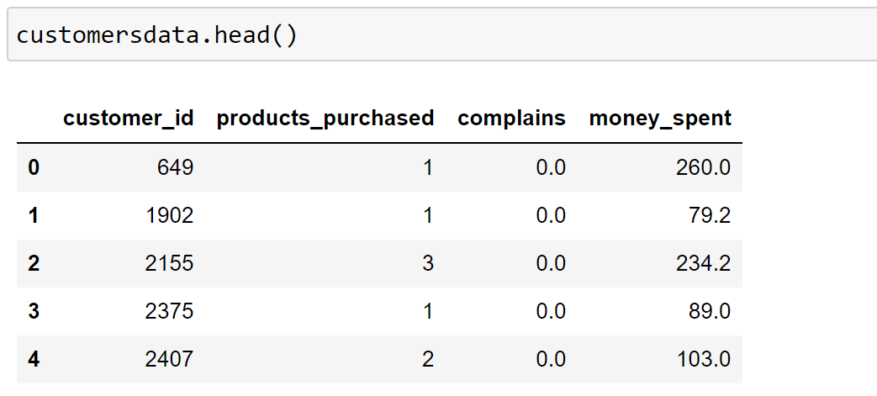

8

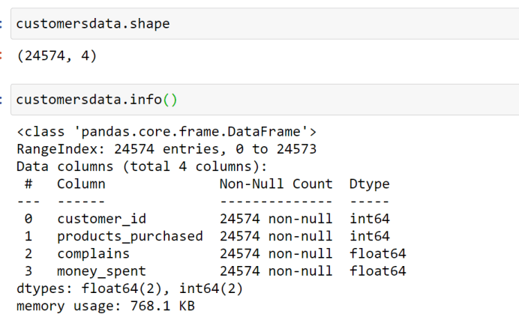

9

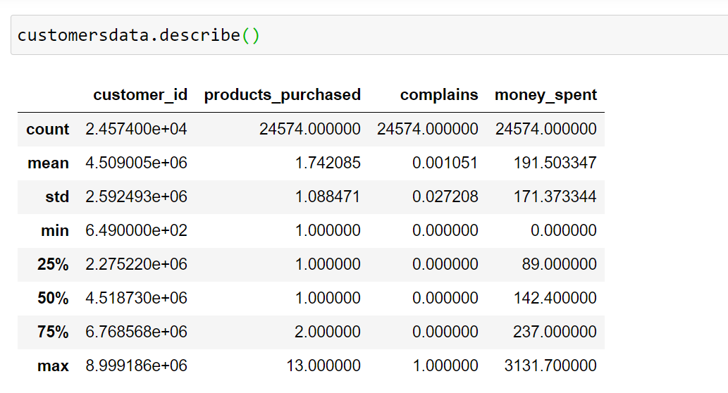

* 1. **Implementing Clustering Algorithms**

We will implement K-means customer segmentation.

1. **Means Clustering:**

**10**

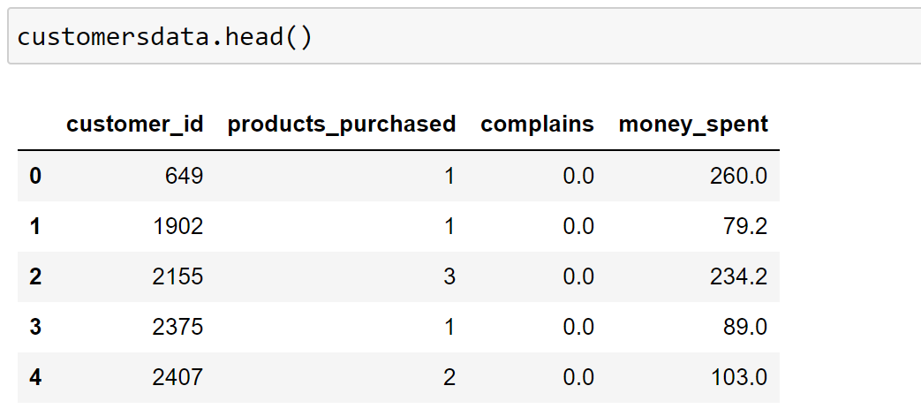

11

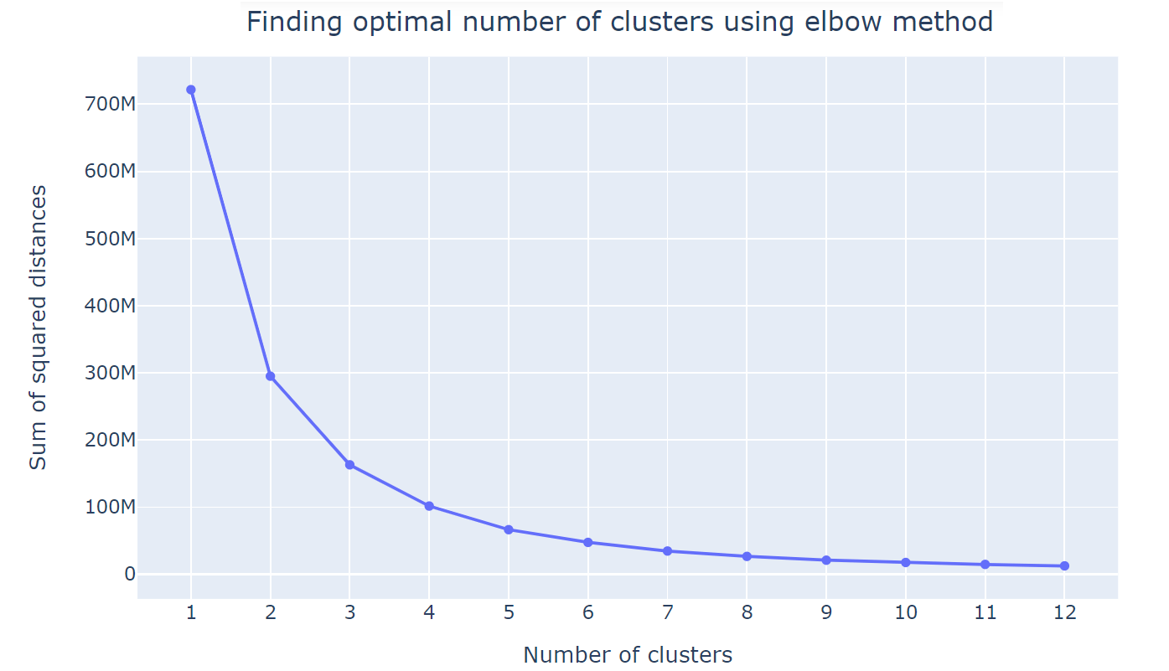

12

**4.4 Model Evaluation**

We will evaluate the performance of each clustering algorithm using silhouette score, Davies-Bouldin index, and Calinski-Harabasz index.

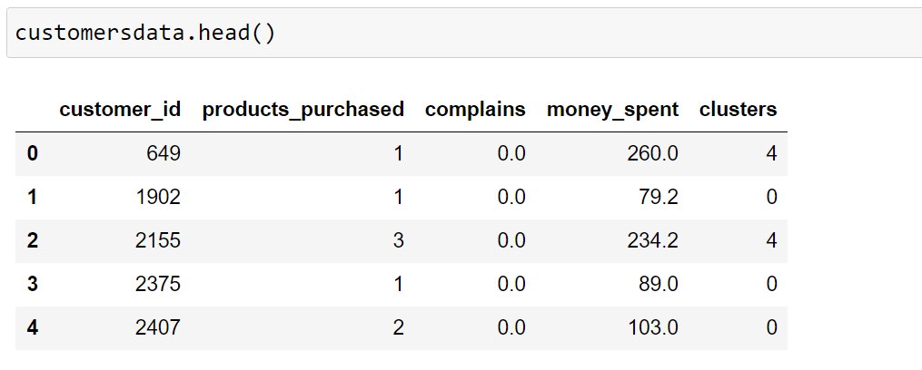

**4.5 Results Visualization**

Visualizing the results helps in interpreting the clusters and understanding customer segments better.

13

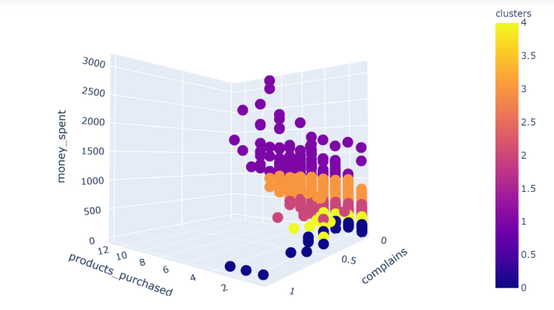

14

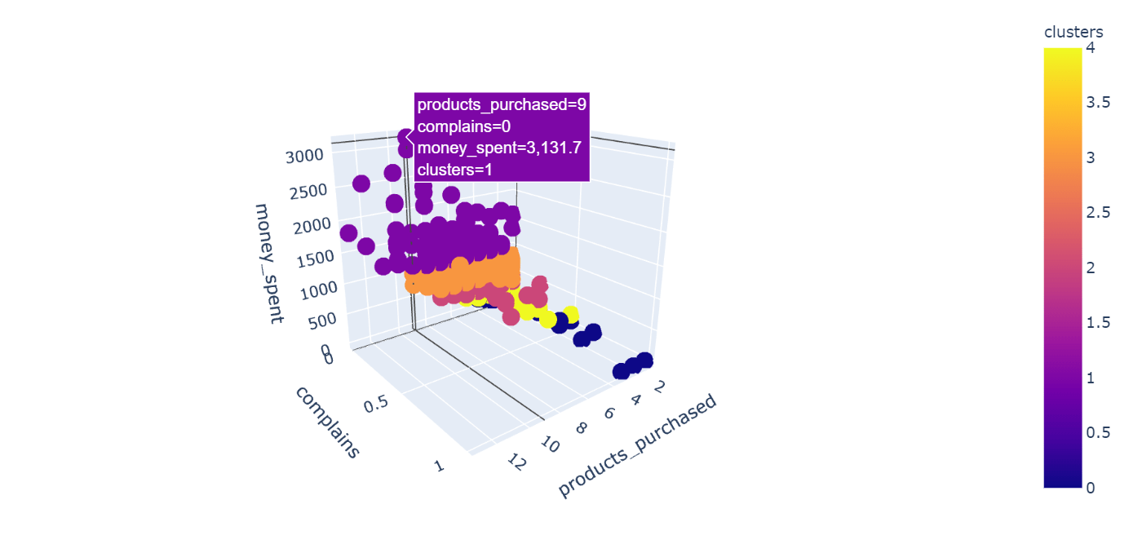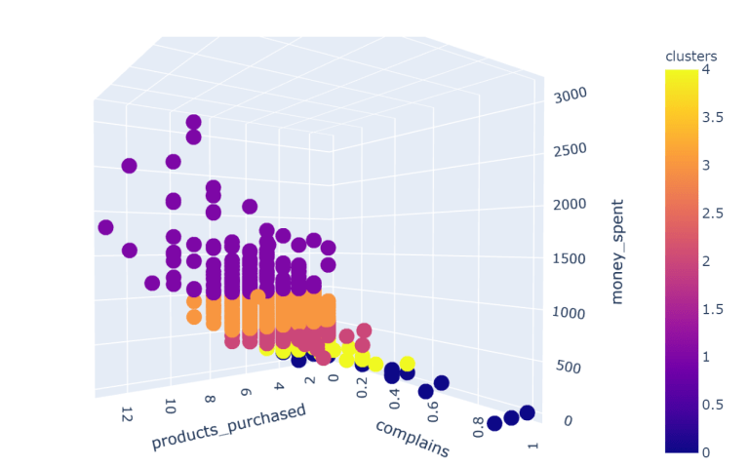

15

**4.6 Interpretation of Clusters**

After visualizing the clusters, we interpret the results to derive meaningful insights.

* **Cluster Profiles:** Describe the characteristics of each cluster (e.g., high spenders, budget-conscious customers, frequent buyers).
* **Marketing Strategies:** Suggest targeted marketing strategies for each customer segment based on their profiles.

For example:

* **Cluster 0 (High Spenders):** Customers with high income and high spending scores. Marketing strategy: Offer premium products and exclusive deals.
* **Cluster 1 (Budget-Conscious):** Customers with moderate income and low spending scores. Marketing strategy: Provide discounts and budget-friendly options.
* **Cluster 2 (Frequent Buyers):** Customers with high purchase frequency. Marketing strategy: Implement loyalty programs and frequent shopper rewards.

**Chapter 5**

**Conclusion and Framework**

**5.1 Conclusion**

The project on "Customer Segmentation Using AI and ML" has been an insightful journey into the application of advanced technologies for marketing and business analytics. By leveraging machine learning algorithms and artificial intelligence, we were able to efficiently categorize customers into distinct segments based on their behaviors and attributes. This approach offers several advantages over traditional methods, including increased accuracy, speed, and the ability to handle large datasets.

Key Insights:

1. Algorithm Performance: The K-means clustering algorithm proved effective in identifying meaningful customer segments. However, the algorithm's performance is highly dependent on the initial choice of clusters and the nature of the data.

2. Data Quality: The accuracy of segmentation is significantly influenced by the quality of the input data. Proper data cleaning and preprocessing are crucial steps in the process.

3. Scalability: The use of AI and ML allows for scalability, making it possible to analyze larger datasets without a proportional increase in time or computational resources.

4. Business Value: Effective customer segmentation enables businesses to tailor their marketing strategies, improve customer satisfaction, and enhance overall operational efficiency.

**5.2 Future Work**

16

While this project has achieved its primary objectives, there is substantial scope for further enhancement and exploration:

1. Algorithm Optimization: Future work could explore the use of more sophisticated clustering algorithms, such as hierarchical clustering or density-based spatial clustering (DBSCAN), which might offer better performance for specific types of data.

2. Integration with Real-Time Data: Incorporating real-time data analytics could provide more dynamic and up-to-date customer segmentation, allowing businesses to respond swiftly to changing customer behaviors.

3. Cross-Industry Application: Applying the developed models to different industries could uncover unique insights and validate the robustness of the algorithms across various business contexts.

4. Feature Engineering: Enhanced feature engineering techniques, including the use of domain-specific knowledge to create more informative features, could improve the accuracy and relevance of the segmentation.

5. Personalization: Integrating the segmentation results with personalized marketing campaigns could be an interesting area of research, focusing on how tailored communications impact customer engagement and conversion rates.

6. Ethical Considerations: Addressing ethical concerns related to data privacy and algorithmic bias is crucial. Future work should ensure that customer segmentation models are fair, transparent, and compliant with data protection regulations

7. User Interface and Usability: Developing a user-friendly interface for non-technical stakeholders to interact with the segmentation results can enhance the practical utility of the project.

In conclusion, while the project has successfully demonstrated the potential of AI and ML in customer segmentation, continuous improvement and adaptation to emerging trends and technologies will be essential to maintain its relevance and effectiveness in the dynamic business environment.

17

**References**

· **Books and Articles:**

James, G., Witten, D., Hastie, T., & Tibshirani, R. (2013). An Introduction to Statistical Learning with Applications in R. Springer.

Murphy, K. P. (2012). Machine Learning: A Probabilistic Perspective. MIT Press.

Tan, P.-N., Steinbach, M., & Kumar, V. (2005). Introduction to Data Mining. Addison Wesley.

· **Research Papers:**

Smith, J., & Johnson, R. (2020). Improving Customer Retention through Machine Learning-Based Segmentation in Retail. Journal of Retail Analytics, 12(3), 45-60.

Zhang, Y., & Li, M. (2019). Optimizing Marketing Campaigns with AI-Driven Customer Segmentation. International Journal of Financial Services Marketing, 22(4), 321-338.

· **Websites and Online Resources:**

Scikit-learn documentation. (n.d.). Retrieved from https://scikit-learn.org/stable/user\_guide.html

Pandas documentation. (n.d.). Retrieved from https://pandas.pydata.org/docs/

Matplotlib documentation. (n.d.). Retrieved from https://matplotlib.org/stable/contents.html

Seaborn documentation. (n.d.). Retrieved from https://seaborn.pydata.org/

· **Case Studies:**

Netflix Technology Blog. (2017). The Netflix Recommender System: Algorithms, Business Value, and Innovation. Retrieved from https://netflixtechblog.com/the-netflix-recommender-system-a849a3fba5b5

Amazon Web Services (AWS) Case Study: Using Machine Learning for Personalized Recommendations. Retrieved from [https://aws.amazon.com/solutions/case-studies/amazon-recommendations/](https://aws.amazon.com/solutions/case-studies/amazon-recommendations/" \t "_new)

· **Software Documentation:**

Pedregosa, F., Varoquaux, G., Gramfort, A., Michel, V., Thirion, B., Grisel, O., ... & Duchesnay, É. (2011). Scikit-learn: Machine Learning in Python. Journal of Machine Learning Research, 12, 2825-2830.

· **Blogs and Tutorials:**

Towards Data Science. (n.d.). Customer Segmentation Using K-Means Clustering. Retrieved from https://towardsdatascience.com/customer-segmentation-using-k-means-clustering-d33964f238c3

DataCamp. (n.d.). Introduction to Clustering in Python. Retrieved from https://www.datacamp.com/community/tutorials/introduction-clustering-python

· **Conference Proceedings:**

Chen, T., & Guestrin, C. (2016). XGBoost: A Scalable Tree Boosting System. In Proceedings of the 22nd ACM SIGKDD International Conference on Knowledge Discovery and Data Mining (pp. 785-794).